These are functional descriptions for version one of a telephone app being prepared for Westchester Community College. The app being developed is a singular app that will be contained within a larger context referred to within this document as WCC MOBILE. We envision that additional apps can and will be developed over time, and that these apps will be incorporated within the WCC MOBILE container.

The name of this first app will be referred to as VIKING TRAIL PATH. Its purpose is to help students, particularly first semester students, navigate the large college campus which consists of numerous classrooms and parking lots located over more than 200 acres.

The first version of the VIKING TRAIL PATH app will contain the following two primary features:

**Feature 1:** Students will be able to enter their course schedule in a grid similar to this:

|  |  |  |  |
| --- | --- | --- | --- |
| **Course Number** | **Class** | **Schedule** | **Location** |
| 10255 | COMSC 110 | Mo 9:00AM - 11:50AM We 9:00AM - 10:50AM | Technology Bldg 25-D |
| 11179 | ENG 102 | TuFr 8:00AM - 9:15AM | Academic Arts Bldg 0305 |
| 10220 | MATH 191 | MoWe 2:00PM - 3:50PM | Technology Bldg 120 |

Based on the information they enter into the grid, a resizable campus map will appear on their phone screen (see figure)

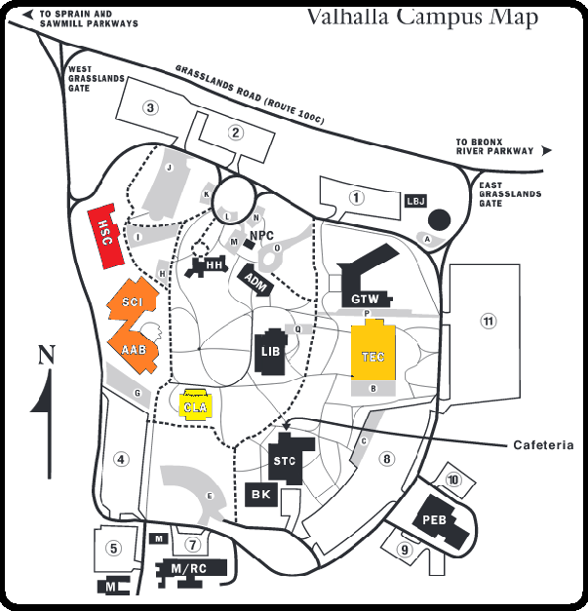

On any given day, the location of their classes will be color coded on the map with color gradations based on the immediacy of their next class. For example, a red color might indicate their next class; an orange color might indicate the class after that, etc.

Students will only have to enter their schedule information once. Once the data is entered, it will be stored on a local database residing within the phone itself.

Note: Later enhancements (version two) will allow students to access MyWCC and automatically download their schedule to the grid. Also envisioned (version two) will be the ability for students to look several days ahead to see the order of their classes on some future date.

**Feature 2:** Students will be able see their exact location within the campus (see figure) and will also be able to “pin” a location (see figure)

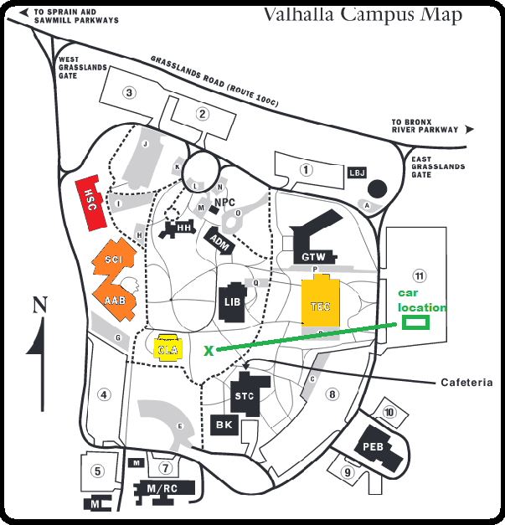

An example of this feature is illustrated using this scenario:

Upon parking their car in the morning, students will be able to “pin” the location of their car (i.e., enter the GPS coordinates of their parked car). When students are ready to return home, they will use the app to locate their current location (“you are here”) and the location of their vehicle.